Meta Title:

Mukhtar Car Auctions | UAE's Transparent Used Car Marketplace

Meta Description:

Experience stress-free used car buying in the UAE. 150-point checks, fair pricing & UAE-ready vehicles. Join thousands of satisfied owners today.

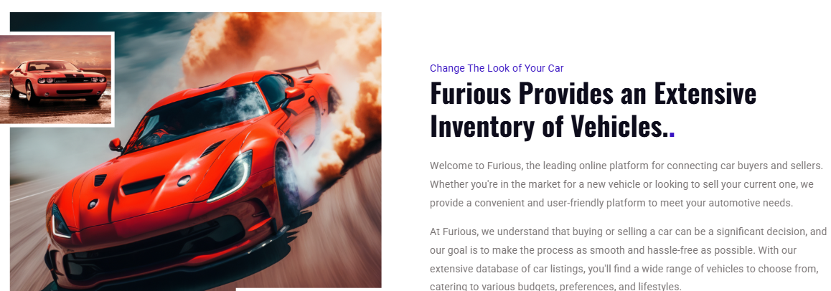Your UAE Used Car Journey Starts Here

Great Rides Don’t Need New Price Tags

We’re Mukhtar Car Auctions, your trusted partner in the UAE’s vibrant car community. Tired of questionable deals and overpriced vehicles? We were, too. That’s why we created a transparent marketplace where you can confidently buy used cars UAE style.

Our extensive inventory features premium pre owned luxury sedans, reliable family SUVs, and value packed daily drivers. Every vehicle undergoes strict quality checks because we believe you deserve clarity, not pressure. Discover why thousands of UAE residents choose us for their automotive needs.
Get A Quote

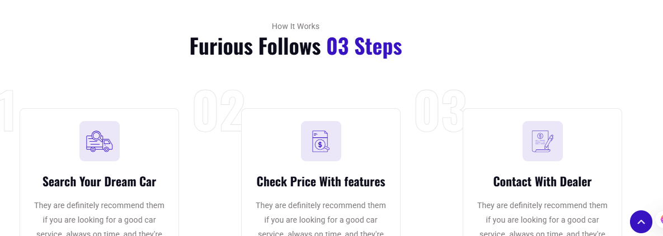How It Works

Simple, Secure, Stress-Free

Search Your Dream Car | Check Price With Features | Contact the Dealer
Browse hundreds of used cars like Luxury sedans or family SUVs. Every listing shows actual photos and dealer ratings. | See pricing breakdowns with inspection reports and service history. No surprises when you buy a used car from us. | Message verified dealers for test drives at your convenience. Our team steps in if questions arise when you buy a car.

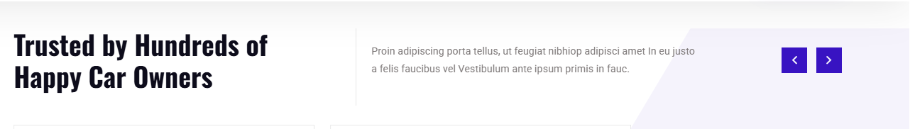Trusted by UAE’s Smartest Drivers

Thousands of residents like you have found their ideal vehicles through Mukhtar Car Auctions. We’ve facilitated over 300+ sales by focusing on rigorous checks, honest pricing, and real support.

